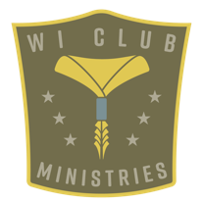
Pathfinder Club Code of Conduct

Pathfinder agreement
I will
Be kind to others.
Use good manners.
Listen quietly to others.
Follow directions.
Be positive.

If I don’t follow these rules, the Pathfinder director may:
- Ask me to change my behavior
- Remove me from a meeting/activity, and discuss steps to correct behavior
- Ask a parent/guardian to assist in resolving behavior
- Request a parent/guardian to attend future meetings and activities
- Seek assistance from the local church pastor or the Wisconsin Conference Youth Director to find an alternate activity for the Pathfinder which may include no longer being a member of the Pathfinder Club.

Important Notice:
Some situations call for immediate suspension from Pathfinders. These include, but are not limited to:
drug and alcohol distribution or use, bullying, physical or verbal sexual harassment/assault, and
bringing a weapon to Pathfinder meetings or activities, both on and off of the church campus.

Pathfinder’s signature______________________________________________________________ Date________________________

Parent/Guardian’s signature_______________________________________________________ Date________________________

