
Adventurer Club Membership Application Form

I would like to join the ________________________________________________________________________________________ Club.
I will attend club meetings, hikes, camping and off-site activities, missionary adventures and other club activities. I agree to be guided by the rules of the club and the Adventurer Pledge and Law.

Adventurer Signature_________________________________________________________________________________________

The Adventurer Pledge
Because Jesus loves me
I will always do my best

The Adventurer Law
Be obedient
Be pure
Be true
Be kind
Be respectful
Be attentive
Be helpful
Be cheerful
Be thoughtful
Be reverent
The Adventurer Logo
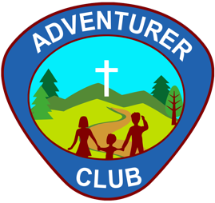

Registration Fee $_________________________ Club Dues $_________________________ Insurance $_______________________

Address______________________________________________________________________________________________________________
Street City State Zip

School____________________________________________ Grade_________________ Church___________________________________

I have been an Adventurer: YES/NO If yes, where? ____________________________________________________________

My dad is a Master Guide: YES/NO My dad has been an Adventurer/Pathfinder: YES/NO

My mom is a Master Guide: YES/NO My mom has been an Adventurer/Pathfinder: YES/NO

Approval by Parents or Guardians
The applicant must be in at least 4 years old (in some clubs, there may be an allowance for younger applicants, but that is up to individual directors). We have read the Adventurer Pledge and Law and are willing and desirous that the applicant become an Adventurer. We will assist the applicant in observing the rules of the Adventurer organization. In consideration of the benefits derived from membership, we hereby voluntarily waive any claim against the club or against the Wisconsin Conference of Seventh-day Adventists for any accidents which may arise in connection with the activities of the Adventurer Club.

As parents, we understand that the Adventurer Club program is an active one for the applicant. It includes many opportunities for service, adventure, and fun. We will cooperate:
- By learning how we can assist the applicant and his leaders.
- By encouraging the applicant to take an active part in all activities.
- By (one or both parents) attending all club meetings and club activities where the applicant is present.
- By assisting club leaders and by serving as leaders if called upon.
- By supplying needed information on the Membership Application and Health Record.

We hereby certify that _____________________________________________ was born on _______/________/______________
Applicant’s Name mo. day year

Parent/Guardian Signature________________________________________________________ Date________________________

