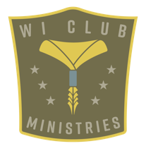
Pathfinder Club Appropriate Touch Policy

Parents/Guardians: Here are some tips for talking to your child about appropriate touch.

Everyone has a body, and your body belongs to you. This means no one can touch you unless you say they can. You should always ask for permission before touching someone else. Don't touch them unless they say you can. There are four personal body zones where you should not touch anvone, and no one should touch you. They are your mouth, chest, between your legs, and your buttocks.

Do you know the difference between safe touch and unsafe touch? Safe touch Is good for you and makes you feel happy. Unsafe touch makes you feel bad, angry, scared, and embarrassed. Someone could touch you in your personal zones, show you photos or videos that make you uncomfortable, or they might make you undress or touch their personal zones in front of you. These types of touch and actions are not good for you.
These are unsafe touch.

If anyone touches you in a way that makes you feel bad or touches you in one of your four personal zones, run away from that person and tell an adult, whom you trust, right away. Tell the adult exactly what happened. Remember, what people do to you is not your fault. You are responsible for what you do to other people.

Question 1: What are the four body zones where no one should touch you?
Question 2: What should you do if someone touches you in a way that isn't safe?
Question 3: What are some safe touches that make you feel good?
Question 4: Who are some people you trust that you would talk to if something makes you uncomfortable?

Please sign below to confirm that both Pathfinder and Parent have read and agree to the above policy.

Pathfinder Signature__________________________________________________________Date________________

Parent/Guardian Signature___________________________________________________Date________________

